**NetCams Assembly Instructions**

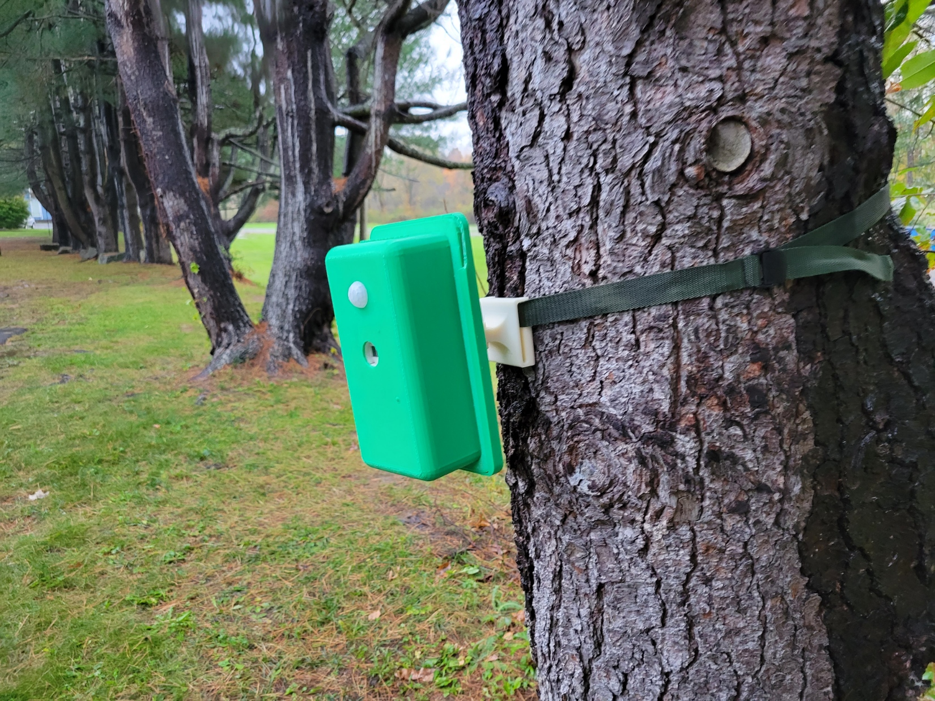

Index.

2. Bill of Materials

4. Labelled pictures of parts

6. Print Instructions and Helpful Tools

7. Assembly Instructions

|  |  |
| --- | --- |
| 1 | High-Temperature Silicone Rubber Tubing for Air and Water - Soft, Durometer 35A, 1/8" ID, 1/4" OD, Opaque White |
| 2 | Heat-Set Inserts for Plastic, Brass, M2.5 x 0.45 mm, 5.9 mm Installed Length |
| 3 | 18-8 Stainless Steel Hex Head Screw, M4 x 0.7 mm Thread, 30 mm Long |
| 4 | 18-8 Stainless Steel Wing Nut,M4 x 0.7 mm Thread |
| 5 | General Purpose 18-8 Stainless Steel Washer,for M4 Screw Size, 4.300 mm ID, 8 mm OD |
| 6 | 3M Super Silicone Sealant, Model 8661, 3 oz. Tube |
| 7 | Black-Oxide Alloy Steel Socket Head Screw, M2.5 x 0.45 mm Thread, 4 mm Long |
| 8 | Partially Threaded Steel Stud, M3 x 0.50 mm Thread Size, 10 mm Long |
| 9 | Light-Duty Buckles for 1" Maximum Webbing Width, Sew-on, Plastic Feed Through Part number |
| 10 | Zinc-Plated Alloy Steel Socket Head Screw, M2 x 0.4 mm Thread, 5 mm Long |
| 11 | Shock-Absorbing Nylon Webbing, 1" Wide, 4 Feet Long, Black |
| 12 | HATCHBOX PLA 3D Printer Filament, Dimensional Accuracy +/- 0.03 mm, 1 kg Spool, 1.75 mm, White |

Parts.

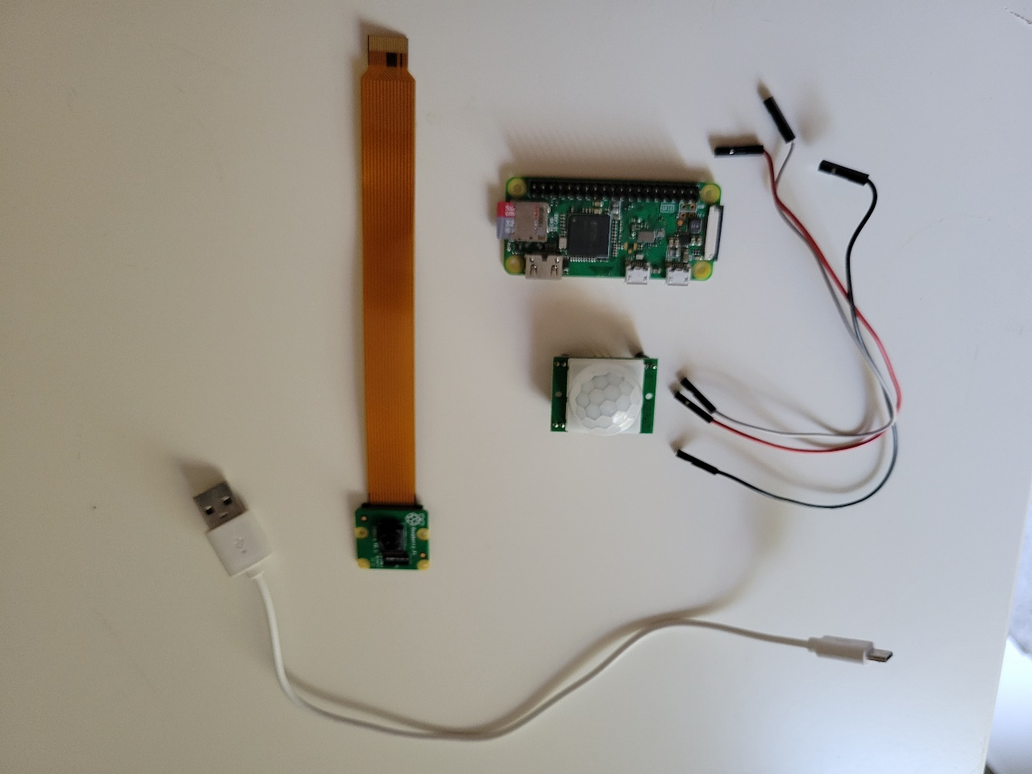

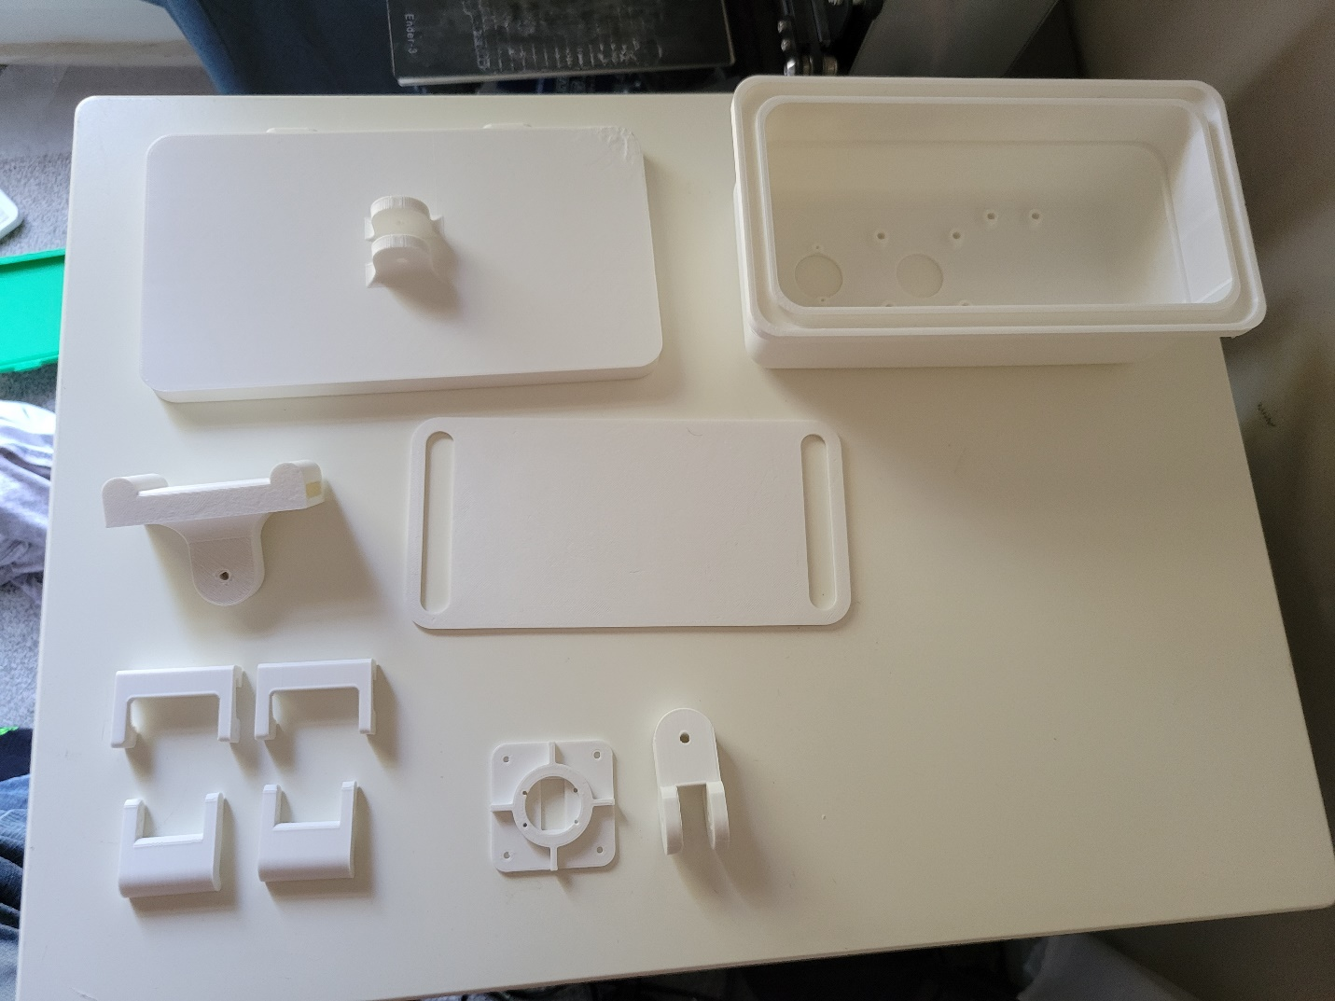

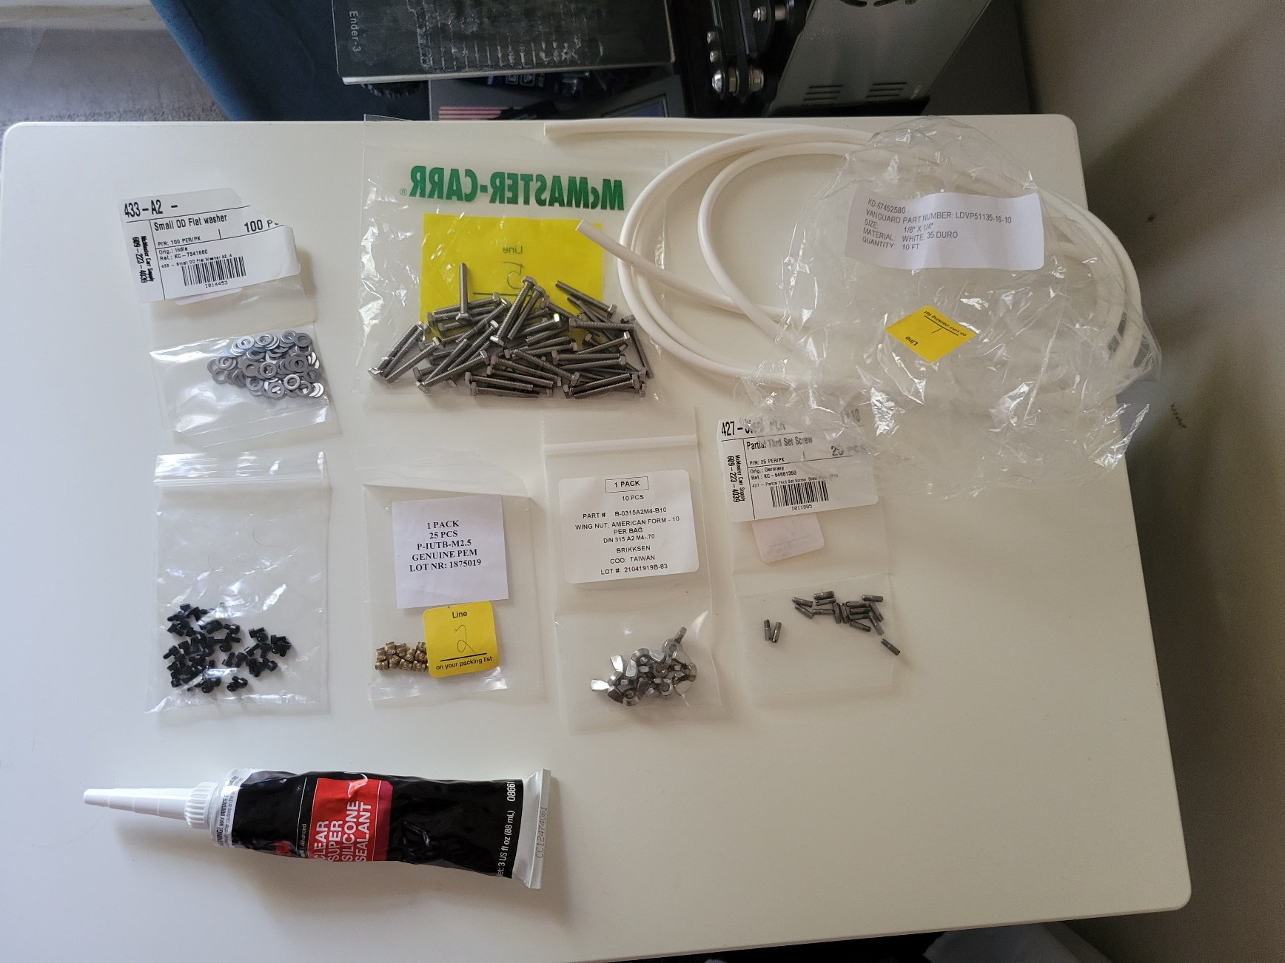

Printing.

This is an overview of the minimum print settings to be used. Increasing resolution and infill density is ok but will take longer to print and use more material.

Minimum print area necessary is 9in x 6in x 5in, larger build plate is preferable to prevent warping and to print many parts at once.

There are Cura project files uploaded to the GitHub. To change the printer, go into the project file and choose the correct printer.

By default, the files are sliced for a Creality Ender 3.

All parts can be printed using .3mm layer height and 2 shells.

Lid: The hinge area needs to be 100% infill, so unless variable infill is available (as in Cura), use 100% for the whole part. Otherwise, the rest of the part can be 25% or greater infill.

Camera Bracket: 100%

Latch: 100%

Mount: 100%

Separator: 25%

Swivel: 100%

Case: 25%

Hook: 100%

Helpful Tools.

* 3mm drill bit
* 4mm drill bit
* Soldering iron
* Small flat head screwdriver
* Knife
* Metric allen key set

Assembly.

1. Use a soldering iron to heat brass inserts (2) into 8 marked holes taking special care to not push the inserts past being flush with the top surface. 225°C is hot enough to easily insert them.

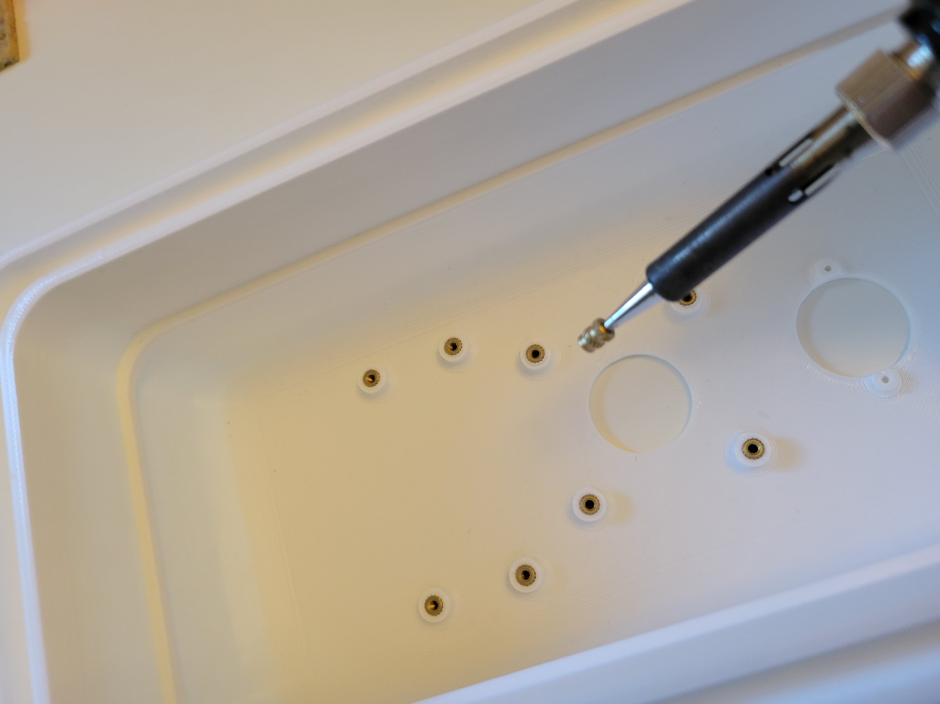

1. Use 4 X Threaded Studs (8) to attach 2 X hinges to the body. If necessary, use a 3mm drill bit to clean up the hole in the

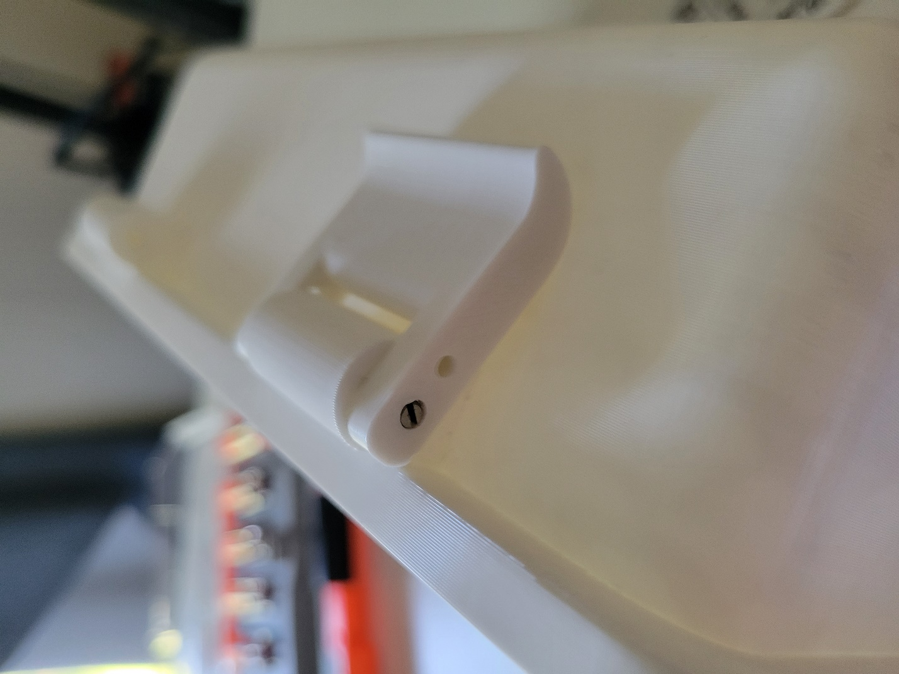

1. Do the same for the latches.

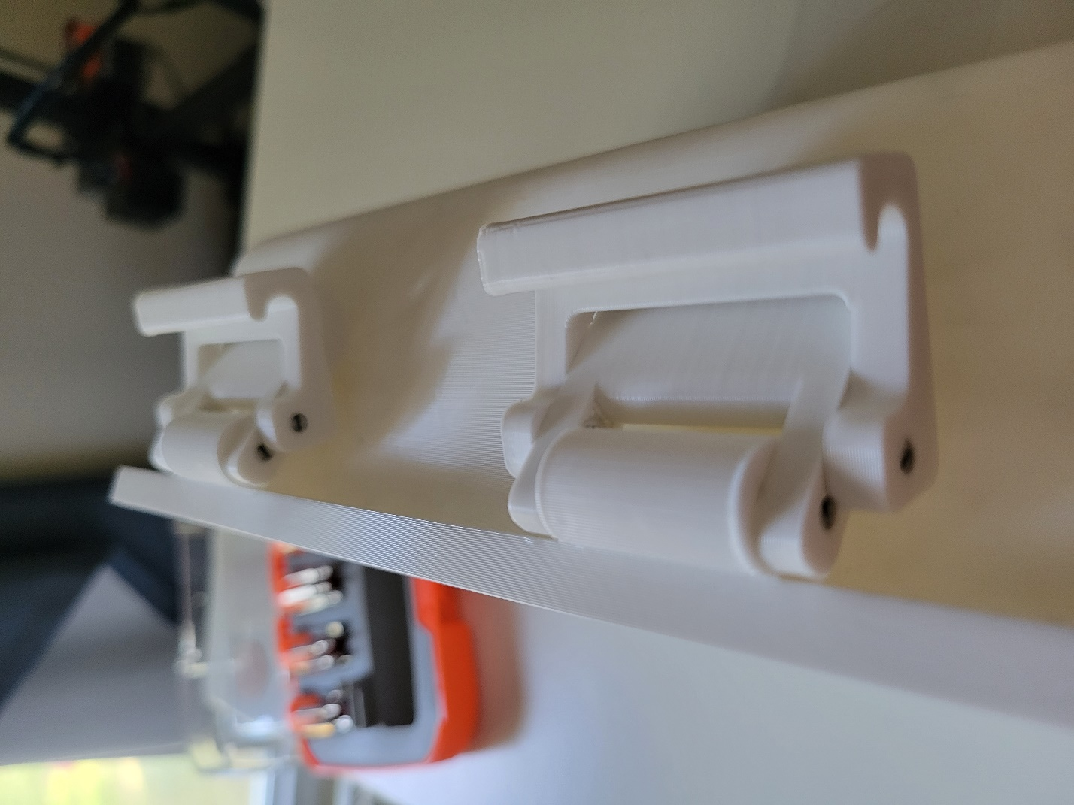

1. Spread the silicone (6) around the middle hole in a consistent pattern. Place a sheet of polycarbonate over the hole, taking care not to get silicone or fingerprints on the hole area. This should be perfectly optically clear. Gently press the edges down making sure that there is a seal all the way around.

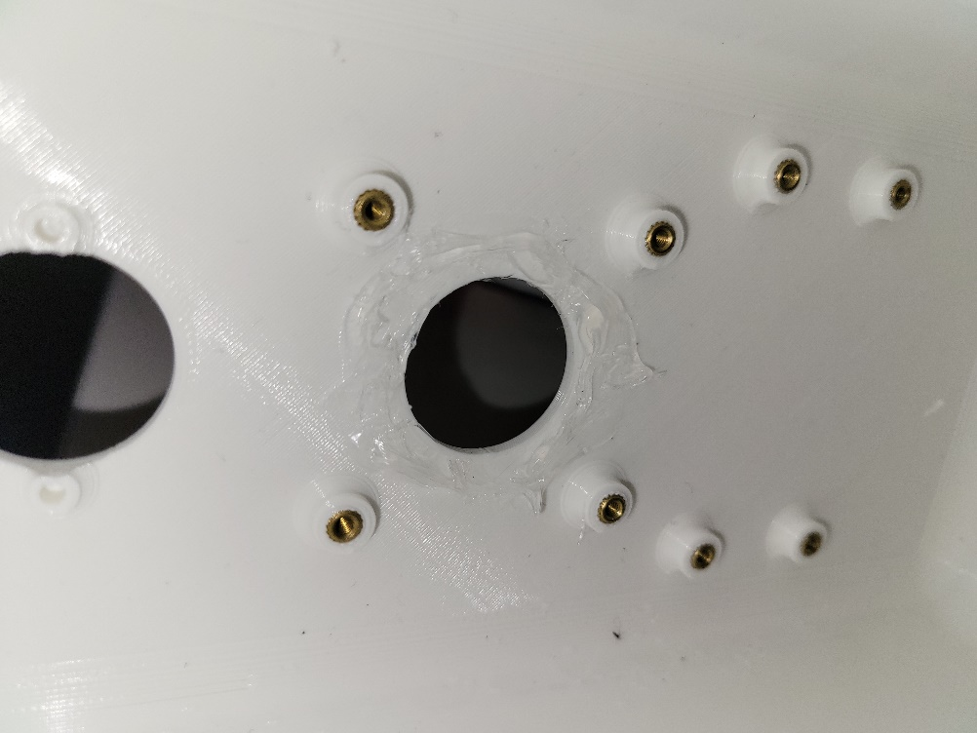

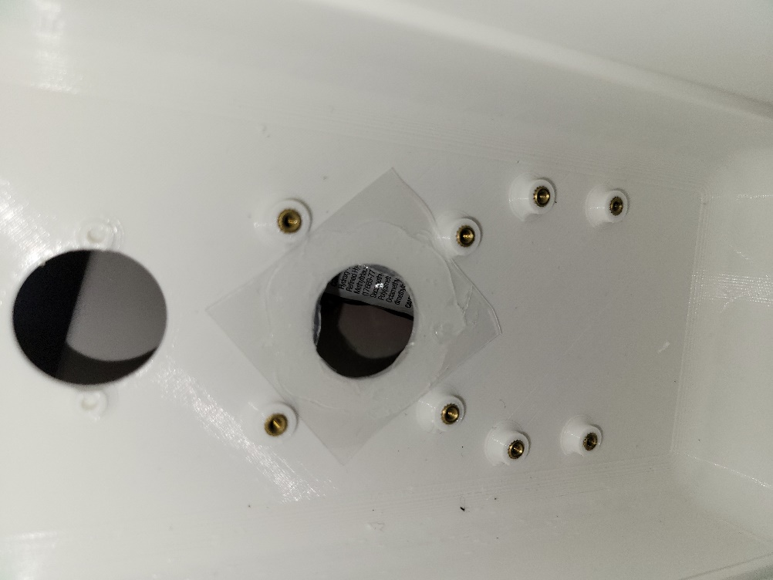

1. Screw in the camera bracket using 4 X M2.5 screws (7). Apply silicone sealant around the PIR sensor hole.

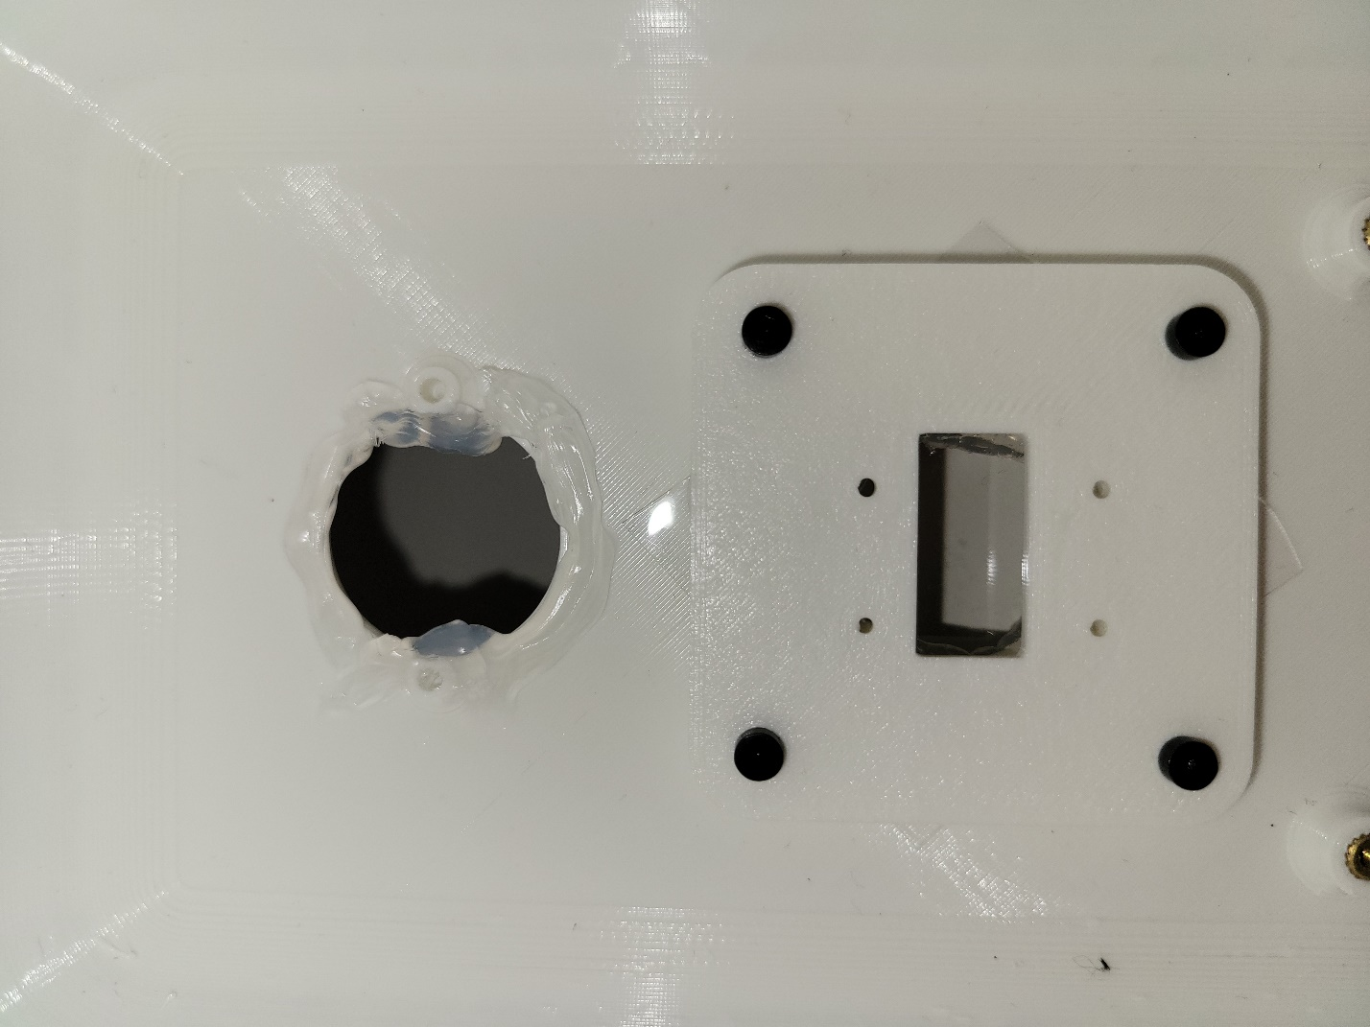

**Note: It’s helpful to use a secondary RPi to check that the camera is focused correctly. Alternately, you could take a photo using the camera trap program and adjust the focus after.**

**Additionally, before installing the RPi or the camera, they should be connected to each other. The RPi should also have its power cable installed.**

1. Now, it’s time to install the electronics. First, use 2 X M2 screws (10) to attach the PIR sensor (top). Use 4 X M2 screws (10) to attach the camera (middle). Use 4 X M2.5 screws (7) to install the RPi (bottom). Connect PIR sensor to RPi as shown.

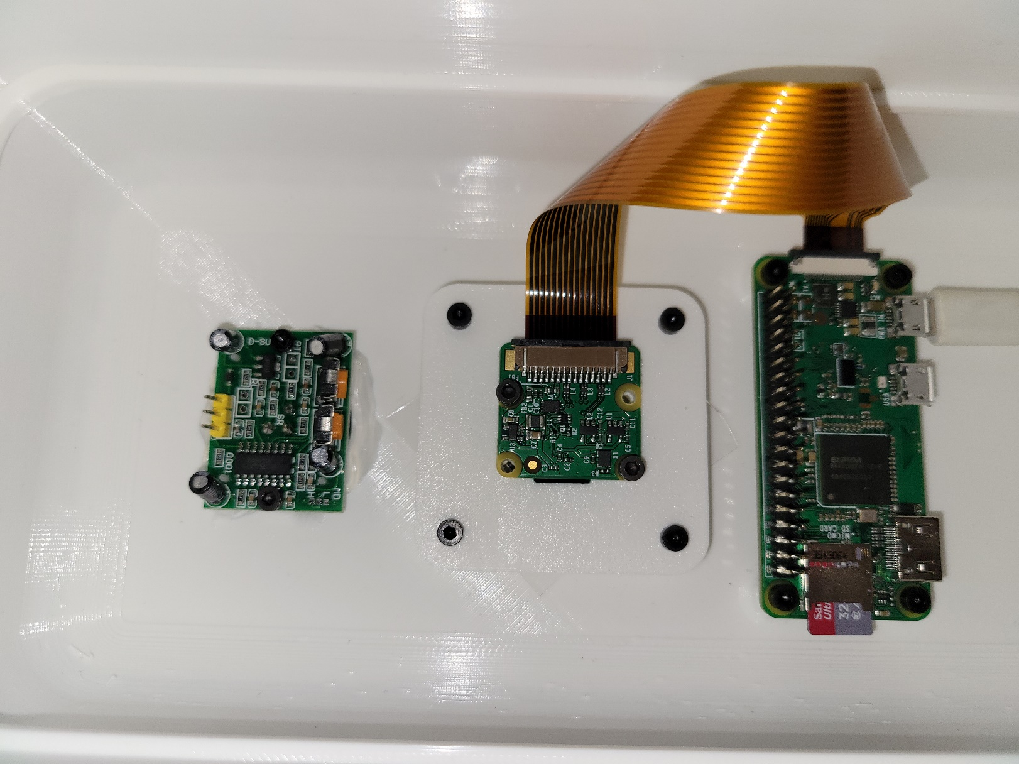

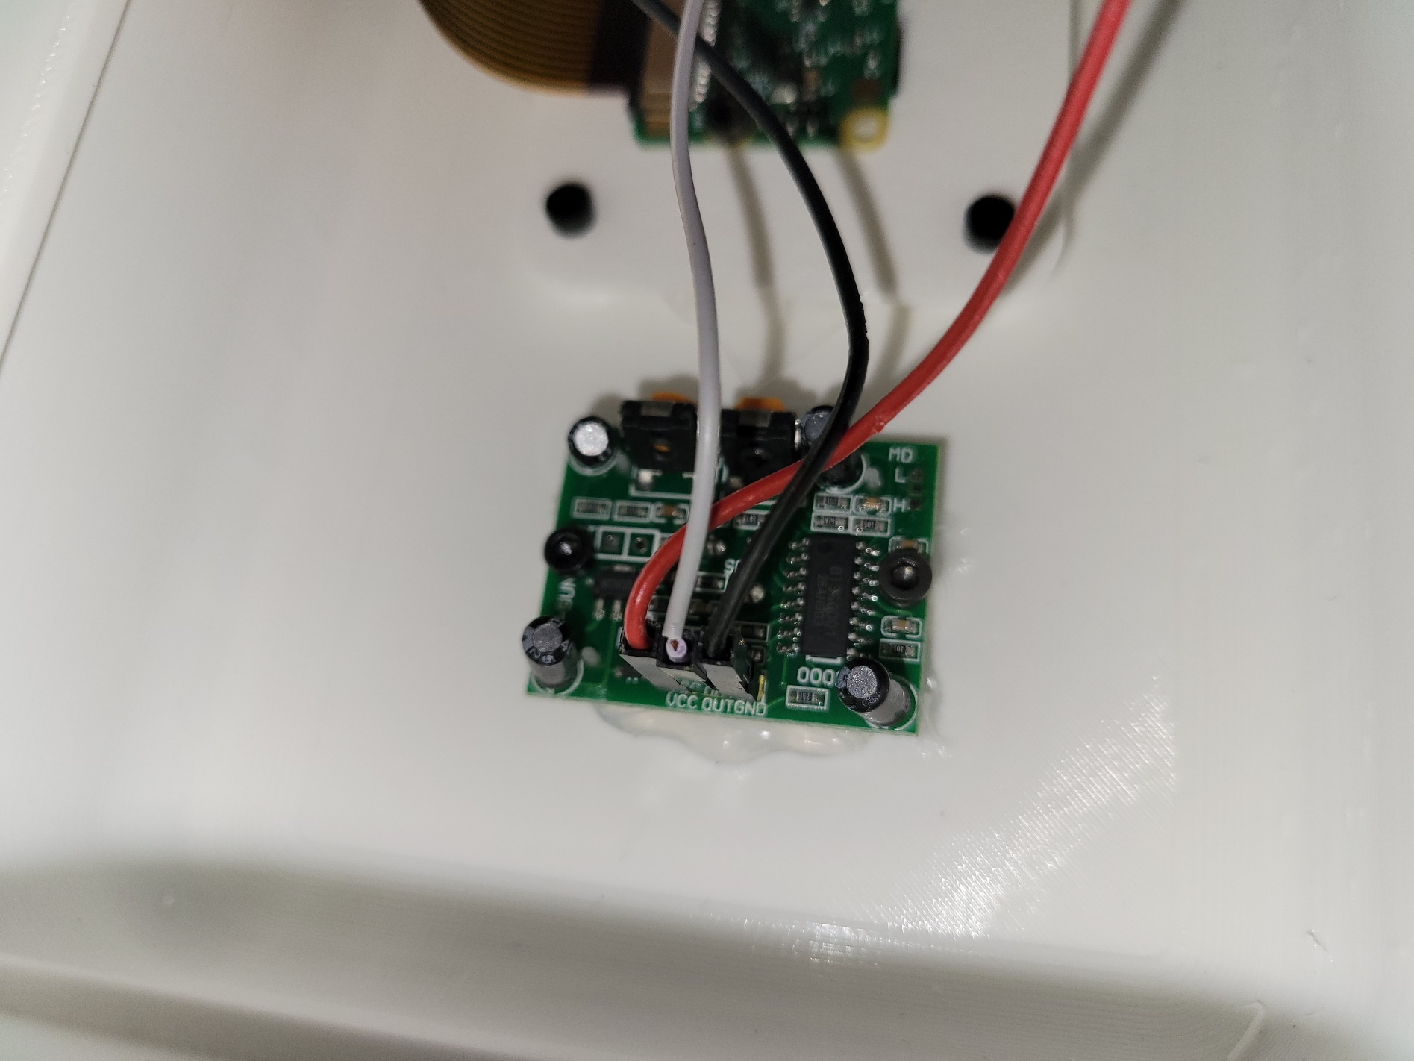

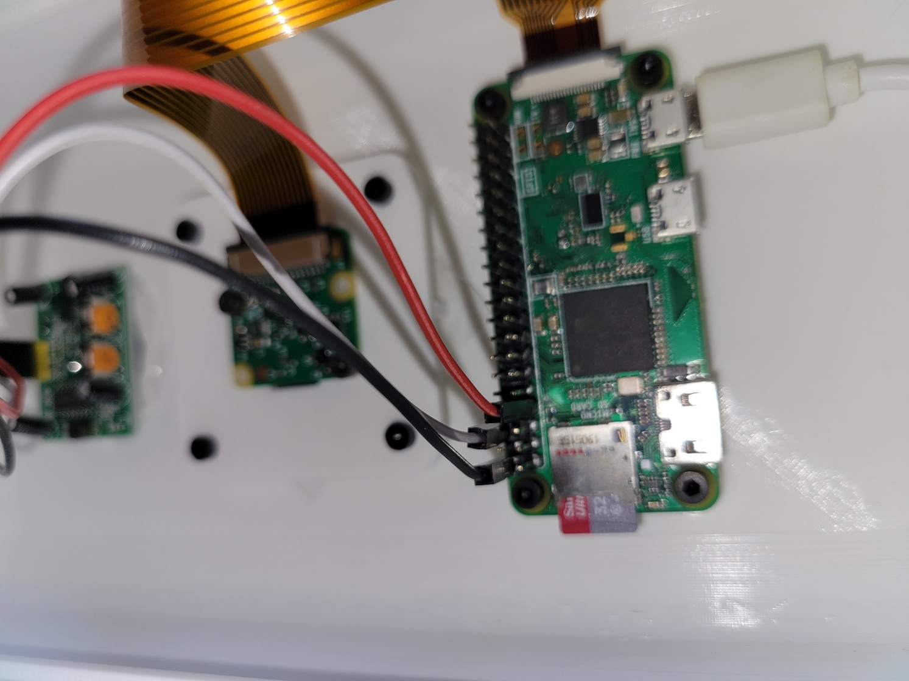

1. Lay the silicone tubing in the channel, taking care to start and end at the bottom of the enclosure. Note the cut leaves an overlap between the start and end of the tube. This creates compression between the two ends and seals better.

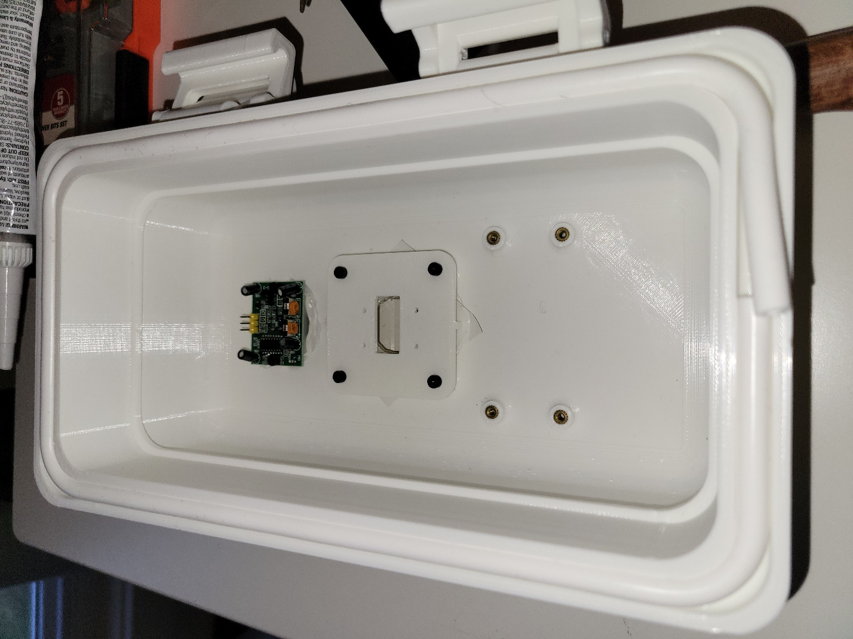

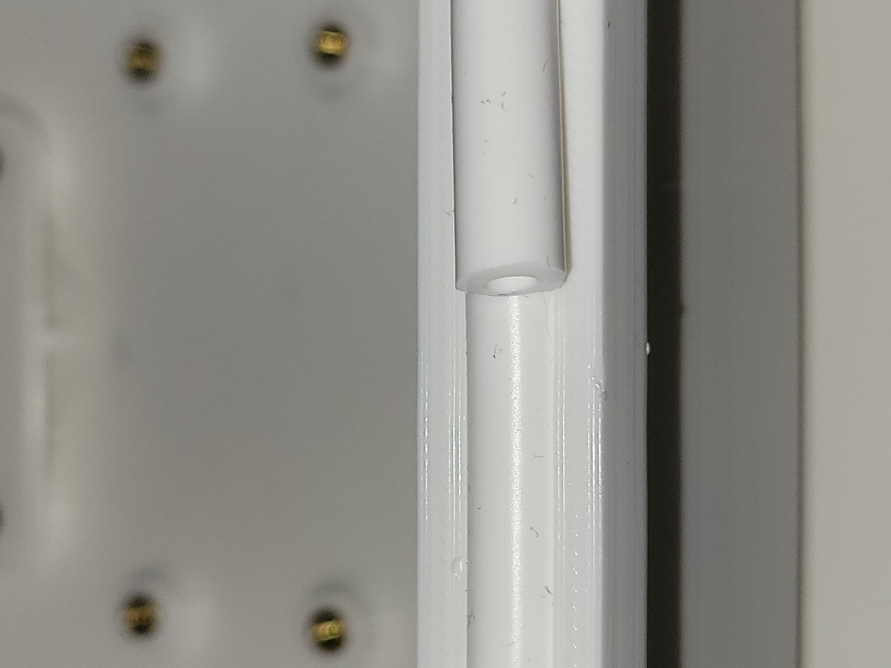

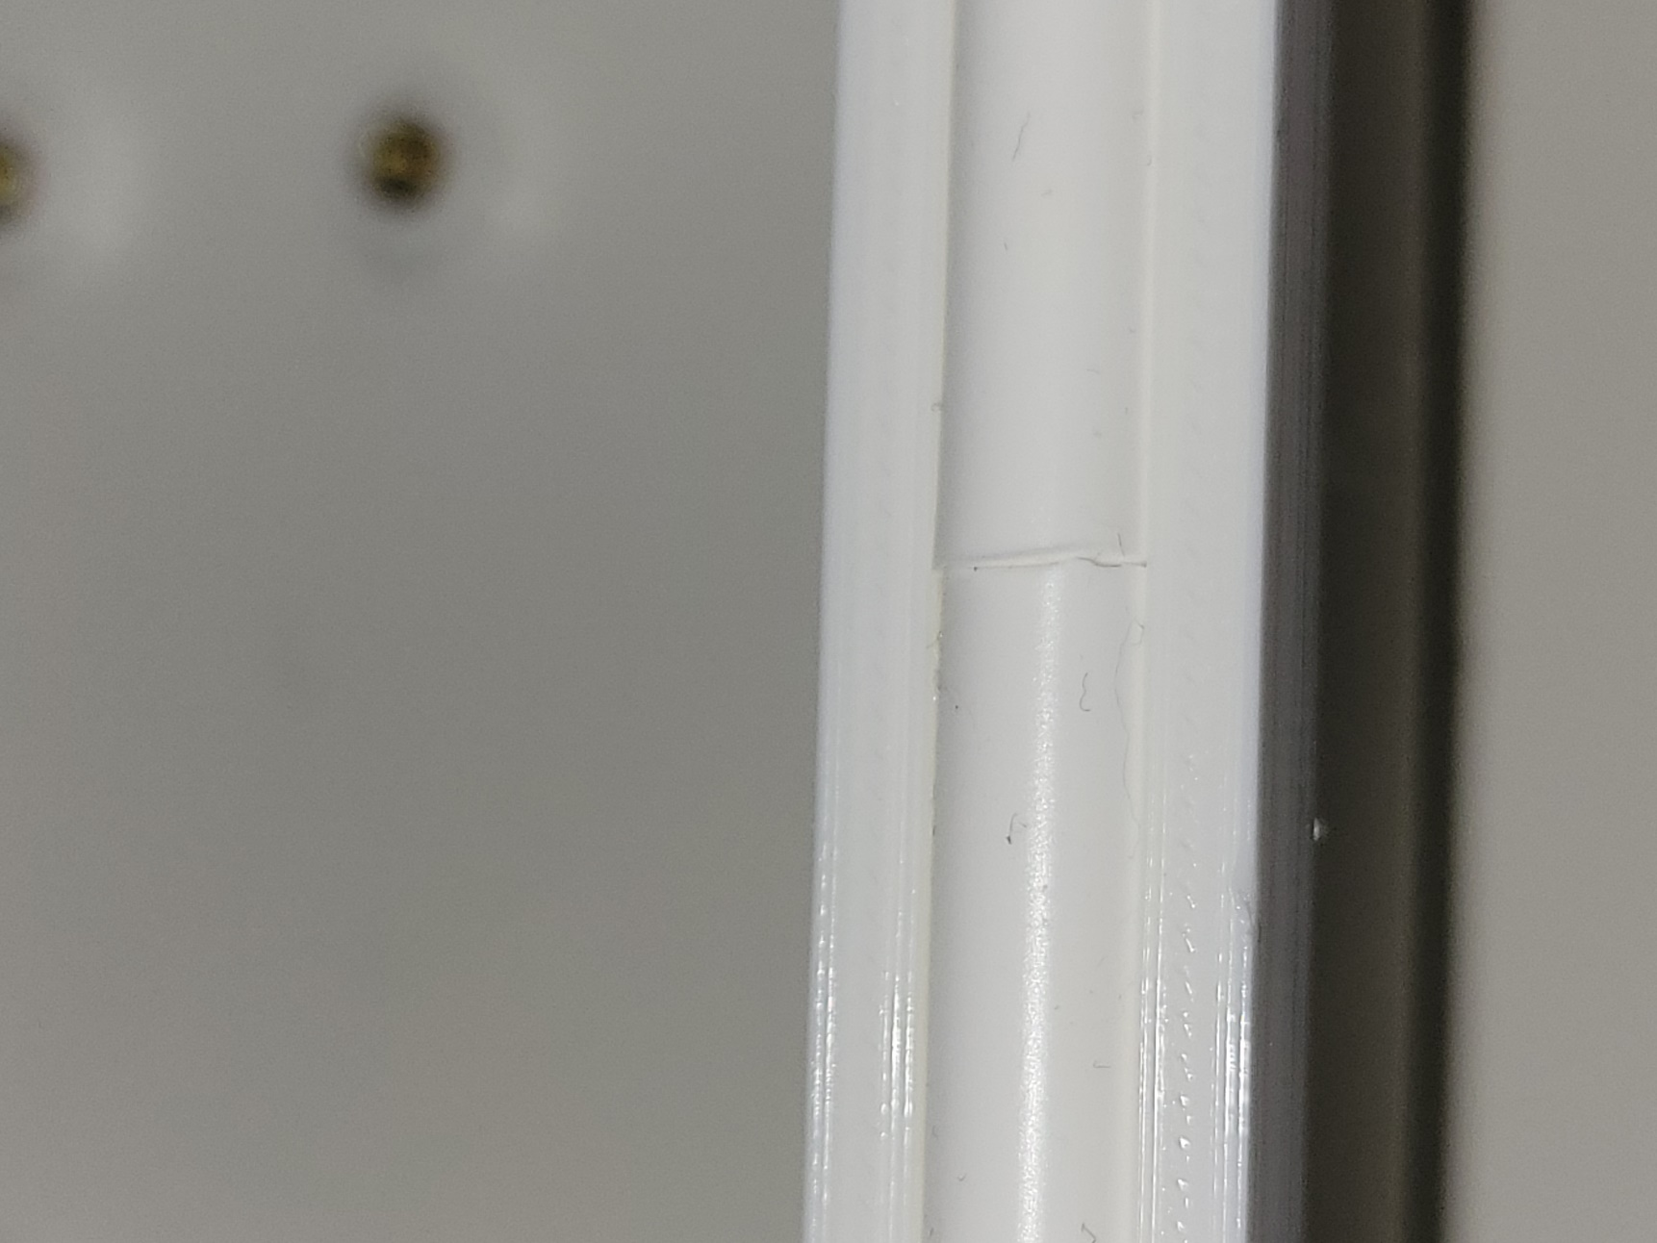

1. Using 4 M4 washer (5), 2 M4 screws (3), and 2 M4 wing nuts (4) to install the mounting hardware as shown.

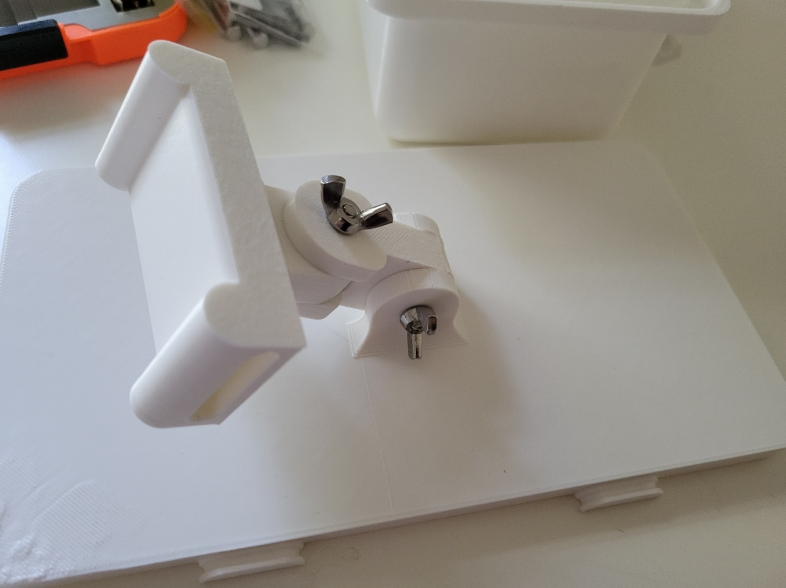

1. Install the seperator with the power cable sticking out of the top end.

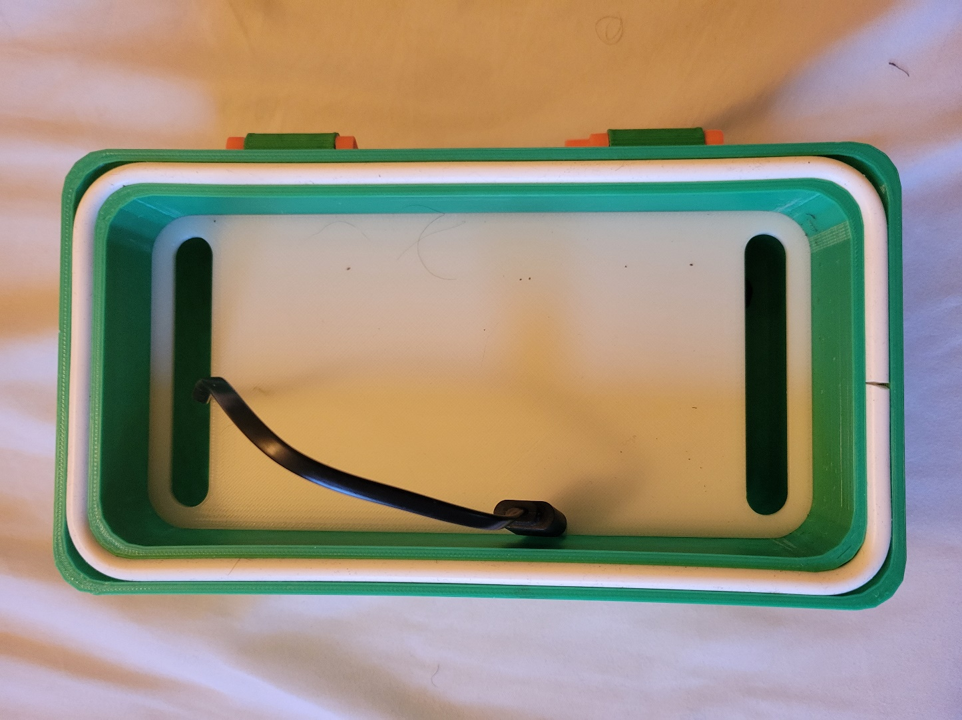

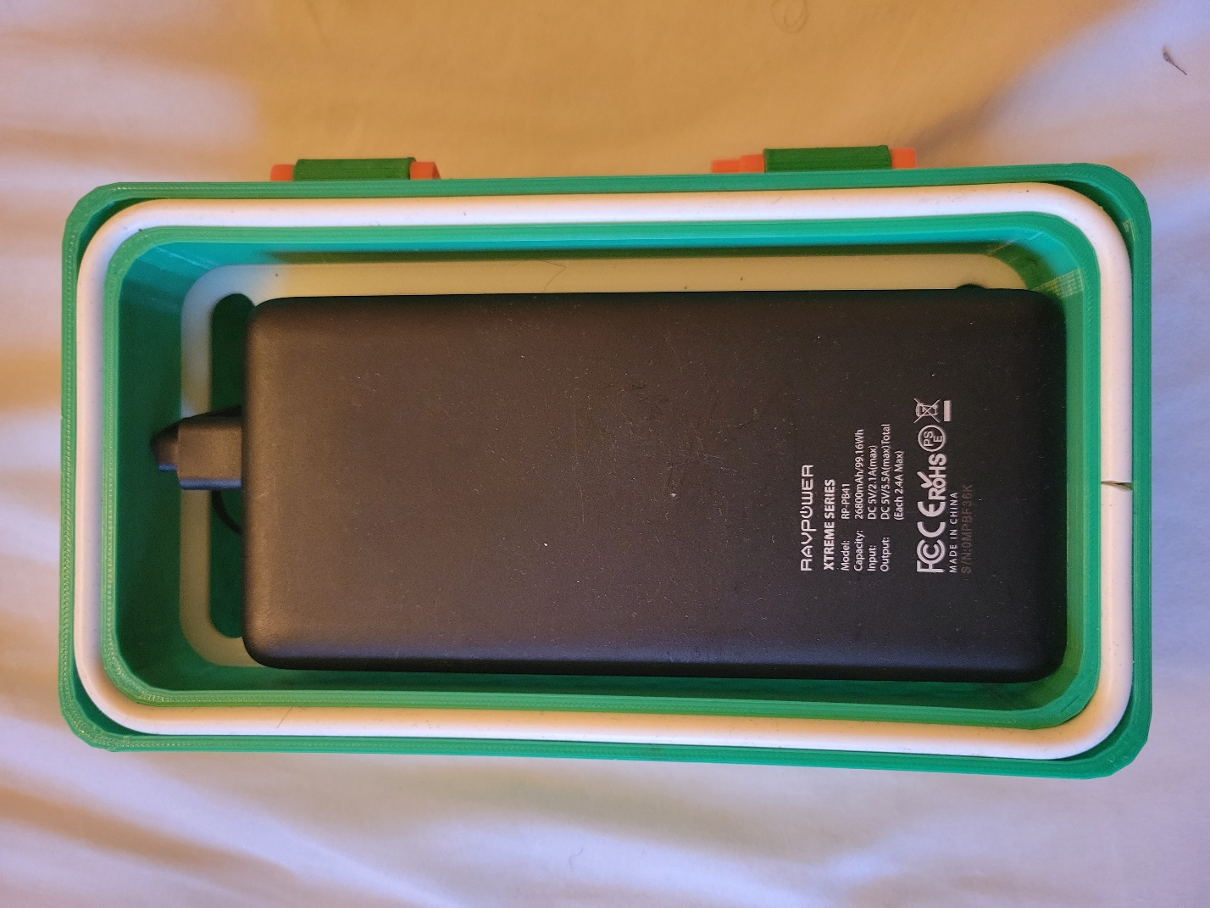

1. . Put the two parts of the enclosure together, and you’ve got yourself a NetCam!

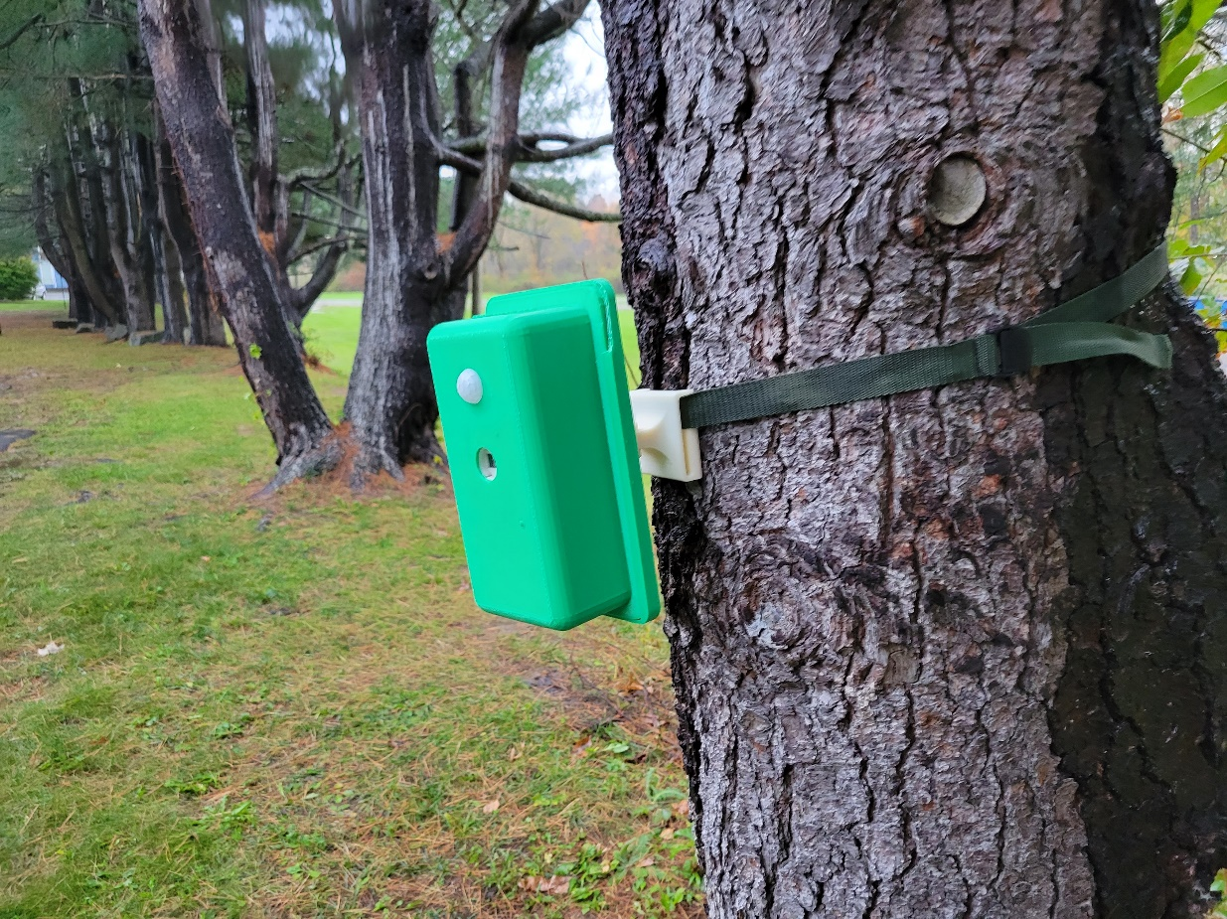

f